Music at the Mansion presents
Somerset Brass Quintet
Mardi Gras Concert
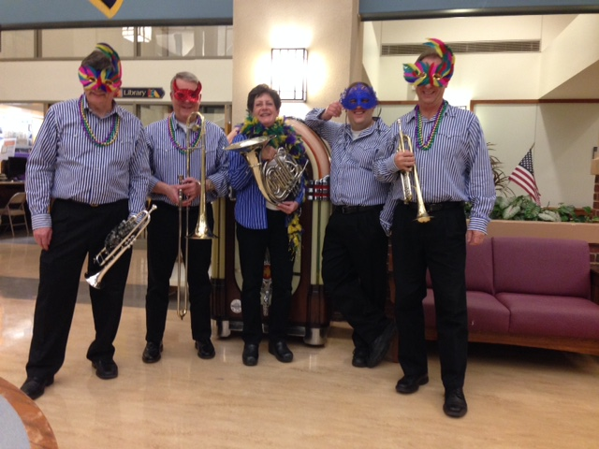
Sunday, February 15, 3:00 PM
Vermeule Mansion
614 Greenbrook Road, North Plainfield
Free Admission Refreshments
Costumes optional – Prize for the best one

