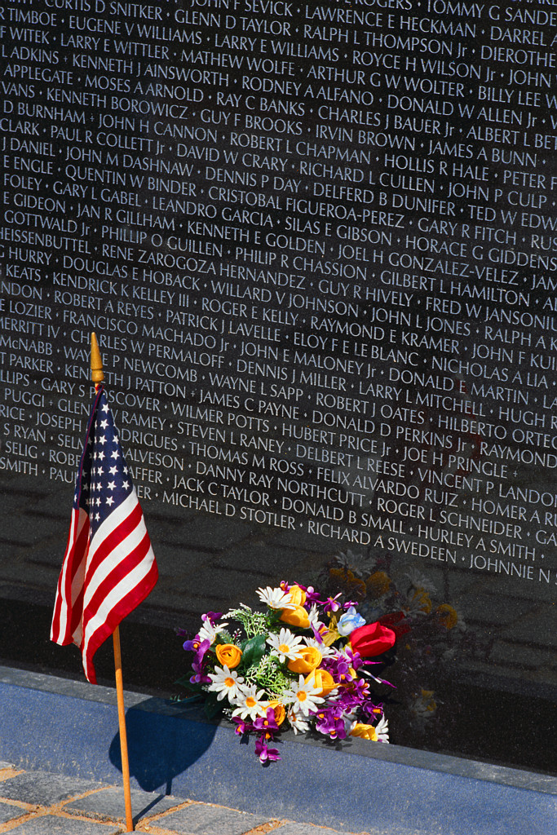

Borough of North Plainfield
2015 Memorial Day Ceremonies
Monday, May 25th, 2015

9:00 AM Vermeule Cemetery

9:30 AM Fire Bell Ceremony @
North Plainfield Fire House

10:00 AM Brook Avenue Cemetery

10:30 AM Monument at the Library

11:00 AM Memorial Park, Willow and
Myrtle at Washington Avenue

In the event of rain, ceremonies will be cancelled.

