CDBG Housing Rehabilitation Program

Somerset County has established a Housing
Program which is designed to assist in improving
County housing. Program funds are used to provide
up to $18,000 of rehabilitation assistance
to income-eligible, owner-occupants of single-family
homes, townhouses, and condominiums.
Regarding townhouses and condominiums, the
County will only make repairs to interior elements that
are not covered by the Homeowners Association.
Moreover, the County will not provide assistance to
Mount Laurel (affordable housing) units, other deed
restricted units or properties held in trust. The
Program does not serve multi-family dwellings.

Assistance is governed by federal regulations and
County policy. Income guidelines are provided in
this brochure.

In general, financial assistance is available for the
renovation or replacement of substandard heating,
electrical, and plumbing systems; some structural repairs
and modifications; insulation and other improvements
designed to reduce operating expenses; alterations to
correct code violations; and other repair work
necessary for upgrading existing homes to standard
condition.

The CDBG Housing Rehabilitation program
provides assistance to eligible homeowners who:
- Meet household income criteria;
- Comply with application procedures and
provide requested personal and financial
information;
- Agree to adhere to program rules; AND
- Have a need to make home improvements
to correct serious housing deficiencies.

This program is not open to residents of
Franklin Township or the Borough of Far Hills.

How the Program Works

Prospective applicants should call Somerset County
Community Development at (908) 541-5756.

- Identify yourself as a Somerset County
resident who would like to be placed on
the Housing Rehabilitation Waiting List

- You will be contacted when your name
reaches the top of the waiting list.
You must respond within 14 days.

- In order to proceed, you must complete an
application, as well as submit personal
information that includes, but is not limited to,
income and asset verification for each person
that currently resides in the home.

- Once eligibility is determined, a home
inspector will make arrangements to visit your
home and prepare a Scope of Work identifying
the necessary repairs.

- Contractors will then come to your home to
prepare a written estimate for the repairs.

- The lowest responsible bidder will be selected
to make repairs to your home.

- The homeowner must sign a depreciating,
ten-year loan.

- Once a lien and contract are signed by the
homeowner, the work will commence.

Eligibility Screening

In order to determine whether this program
is appropriate for you, ask yourself the
following questions:

- Do I own my home?
- Have I lived there 200 days?
- Would I certify that I have not been
previously served by the County or by any
other municipal Housing Rehabilitation
Program? (It is the policy of the County to
serve homeowners one time.)
- Do I meet the income eligibility criteria that
are given in this brochure?
- Am I willing to sign a lien equal to the
amount of assistance that is provided to
improve my home?
- Would I be willing to accept the lowest
bidding contractor to perform work on
my home?
- Do I understand that the Housing Rehab-
ilitation Program will only repair structural
damage or replace equipment that is necessary
for occupancy of my home; i.e.- no cosmetic
repairs, no additions, no garages?
- If it is determined that there is lead-based
paint in my home, would I be willing to
relocate while the associated hazards are
removed?
- Do I understand that there is a waiting list?

If you answered yes to all of these questions, then you
may be eligible to participate in the Somerset County
CDBG Housing Rehabilitation Program.

CALL THE SOMERSET COUNTY
COMMUNITY DEVELOPMENT
OFFICE at (908) 541-5756
Income Limits

In order to receive assistance, the owner
occupant’s household income may not
exceed the income limits that are given
below.

For the purposes of this program, income is
defined as the sum of income including
income from assets of the homeowner
and other members of the household.

Program Year 2012 Income Limits

Family Size Maximum Income

1 $58,800
2 $67,200
3 $75,600
4 $84,000
5 $90,700
6 $97,400
7 $104,200
8 $110,900

*Income limits increase slightly every year.



2013 Somerset County Board of

Chosen Freeholders
Peter S. Palmer, Director
Patrick Scaglione, Deputy Director
Robert Zaborowski
Patricia L. Walsh
Mark Caliguire


Somerset County Community
Development Block Grant (CDBG)
Housing Rehabilitation Program
Funding for this program is provided
by a grant from the U.S. Department
of Housing and Urban Development
(HUD)

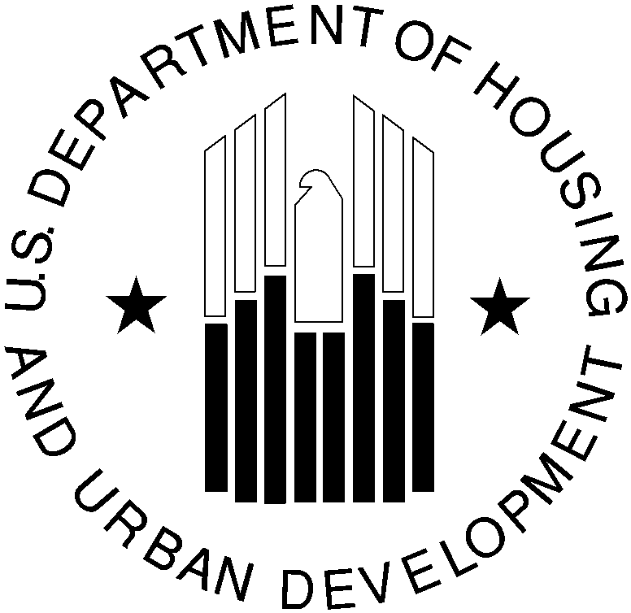Revised 1/13

Somerset County
New Jersey

Housing

Rehabilitation
Program

Providing rehabilitation assistance
to income-eligible owner-occupied households in Somerset County municipalities

For further information, please contact the
Somerset County Community Development
Office at (908) 541-5756 or by email at
commdev@co.somerset.nj.us.

