  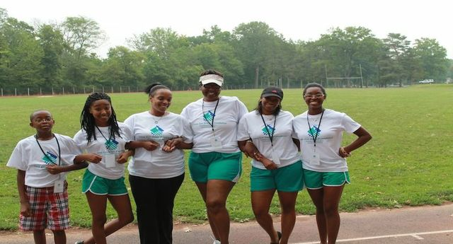
  June 15, 2013
  3K walk for students
  School Supplies Giveaway
  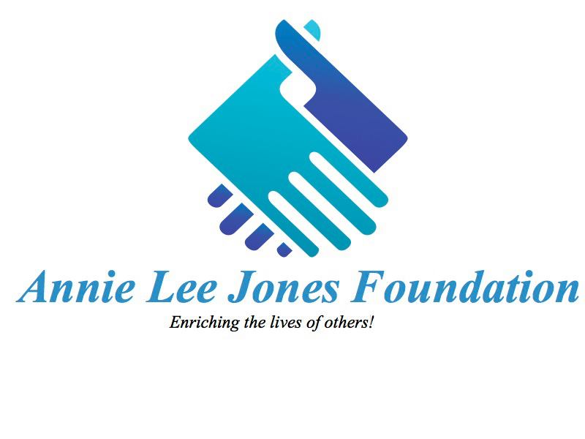
  Annie Lee Jones Foundation is a non-profit corporation that is dedicated to empowering students and helping them excel with excellence. Our mission is dedicated to empowering the youth and creating development events for both the community and the youth. As a foundation that is committed to its community we have taken on the obligation of enriching the lives of others.
  This year our foundation is hosting its 2nd Annual 3K Walk-for-Students-a-Thon, where we raise money for our annual Stuff the Bus-School Supplies Giveaway event. All of the proceeds goes towards providing students with school supplies for the upcoming school year. Last year was our first time running the program and with the support of local companies and institutions we were able to distribute 128 book bags filled with school supplies to students. This year our goal is distribute over 200 book bags! Please join us on June 15th as we walk to enrich the lives of others!
  Annie Lee Jones Foundation
  3k walk-for-students-a-thon
  saturday,
  june 15, 2013
  NORTH pLAINFIELD HIGH SCHOOL: lOWER kRAUSCHE FIELD
  WALNUT STREET
  l
  8:00 am registration
  9:00 am
  walk-A-Thon
  9
  $25 registration
  Annie Lee JOnes Foundation
  P.O. Box 665
  Scotch Plains, NJ 07076
  www.annieleejonesf.org

