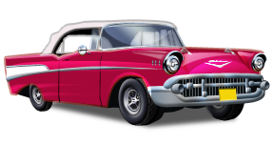
Somerset
Street

2nd Annual Summer Car Cruise

North Plainfield, New Jersey

Cruise begins at Park Place and continues along
Somerset Street to Race Street

Monday, July 16, 2012
6:00pm to 9:00pm

(Rain date Tuesday, July 17th - 6:00 to 9:00 pm)

Hosted by Car Nutz Car Club

This is a free event sponsored by
The Mayors Special Events Committee
FOOD COURT LOCATED IN BOROUGH PARKING LOT ACROSS FROM BOROUGH HALL ~ DJ PLAYING THE “OLDIES” FOR YOUR LISTENING PLEASURE ~TROPHIES WILL BE AWARDED

