Register Now!
Seventh Annual Legal Runaround
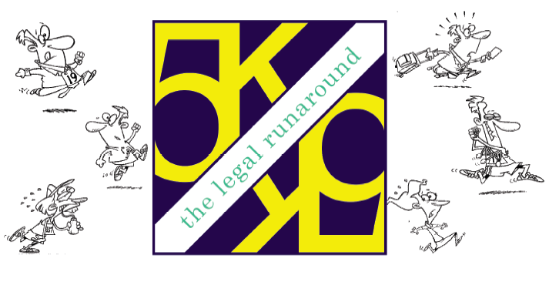
Part of the Tour of Somerville
Memorial Day Weekend!

Thursday, May 24, 2012
5:00 pm Registration / 6:15 pm Kids’ Dashes / 6:30 pm 3K Poker Walk / 7:00 pm 5K
Each participant will receive a Custom Tee-Shirt, free food provided by Verve Restaurant,
and will enjoy DJ music and random prize giveaways! 50/50 Raffle too!

Veteran’s Memorial Plaza
20 Grove Street, Somerville
(across the street from the Somerset County Courthouse)

Presented by the Somerset County Bar Foundation whose past  beneficiaries have included: Middle Earth, C.A.S.A., Somerset County, Project D.A.R.E., Legal Services of NW Jersey, Somerset Treatment, Services, New Jersey Orators, Inc., Community Hope, Inc.  and the Food Bank.  Register On-Line (no online processing fee): www.practicehard.com  Download application at: www.bestrace.com  For more information or to become a sponsor contact the Somerset County Bar Foundation Tel: 908-685-2323 ■ Fax: 908-685-9839 ■ Email: cawinder@somersetbar.com  WORKING FOR OUR COMMUNITY. | 