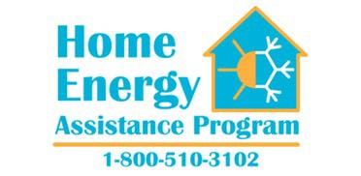

Christie Administration Reminds Residents of April 30th Application Deadline for Low Income Home Energy Assistance Program

The New Jersey Department of Community Affairs (DCA) reminds income-eligible residents that they have until Monday, April 30, to apply for Low Income Home Energy Assistance Program (LIHEAP) benefits for this year. The federally-funded program assists low-income households with their heating and cooling bills, and provides emergency heating system services and emergency fuel assistance.

“The LIHEAP program provides invaluable help to thousands of New Jersey’s most vulnerable low-income households,” said DCA Acting Commissioner Richard E. Constable, III. “Assistance is still available and we encourage people who are eligible to apply if they haven’t done so already.”

Program funding is administered through the DCA’s Division of Housing and Community Resources. Residents are asked to file an application with any of the local agencies participating in the LIHEAP program.

To be eligible for LIHEAP benefits, households must be responsible for home heating or cooling costs, either directly or included in the rent; and have a gross income at or below 200% of the federal poverty level. Persons who live in public housing and/or receive rental assistance are not eligible unless they pay for their own heating/cooling costs directly to the fuel supplier. The amount of the LIHEAP heating benefit is determined by income, household size, fuel type, and heating region.

The LIHEAP application also serves as an application for the Universal Service Fund (USF) Program, which is state funded and administered by the Division of Housing and Community Resources. USF helps low-income households pay for their electric and natural gas costs. LIHEAP eligible households may also be eligible to receive USF assistance. USF applications are accepted throughout the year.

For more information on LIHEAP and USF, or to find the nearest agency participating in the program, please log on to www.energyassistance.nj.gov or call 1-800-510-3102 (LIHEAP).

###

