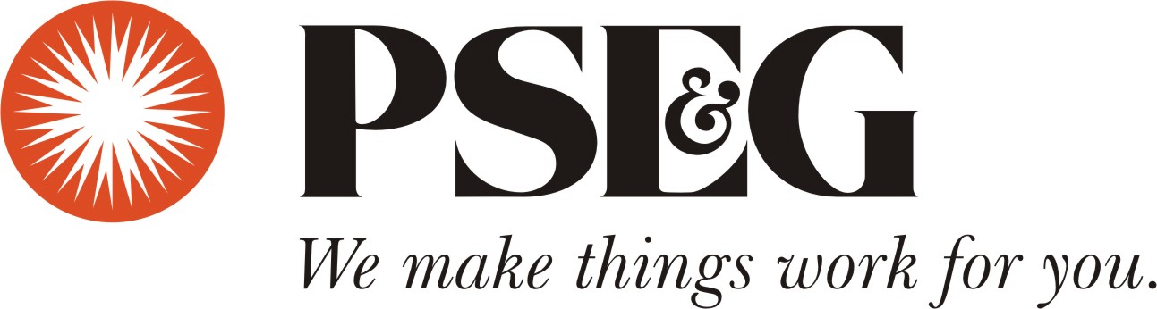
Community Resources for Households Affected by Hurricane Irene

Immediate Assistance

American Red Cross
The Red Cross provides immediate emergency assistance to people affected by disaster, such as; shelter, food and water, health and mental health services to address basic human needs.
To locate your local Red Cross Chapter, go to www.redcross.org.

Information and Referral
Call 2-1-1 by simply dialing 2-1-1 from any phone to learn about your local community resources or visit www.info@211.org.

Disaster Mental Health Hotline
Crisis counselors will provide outreach and education services about coping with the emotional difficulties in the aftermath of emergencies such as these call the New Jersey MentalHealthCares’ Disaster Mental Health Helpline (877) 294-HELP (4357) where experienced crisis counselors can be reached. A TTY line is available at (877) 294-4356. Translation services are available as well.

NJ HELPS
For complete information on all state social services and on-line applications please visit http://www.njhelps.org.

Veterans Benefits 1-800-827-1000 TTY 1-800-829-4833
U.S. Department of Veteran Affairs
Or online at www.va.gov

Help with Your PSE&G Bill
Programs are available to help our customers with their utility bills.
- The Universal Service Fund (USF) 1-800-510-3102
  - Helps make low income customer bills more affordable with a $5 to $150 monthly credit. USF uses the same application as LIHEAP.
- NJ SHARES 1-866-NJSHARES (657-4273)
  - Helps moderate income customers not eligible for low income programs with up to $1000 toward their PSE&G bill.
- NJ Lifeline 1-800-792-9745
  - Helps income eligible seniors and disabled adults with an annual utility credit of $225.
- TRUE GRANT 1-855-465-8783
  - Helps customers not eligible for low income programs with up to $1500 toward their PSE&G bill.
- Salvation Army Red Shield 1-888-302-6100
  - Helps military personnel and their families with utility bills.
- Low Income Home Energy Assistance Program (LIHEAP) 1-800-510-3102
  - Helps with winter heating and medically necessary cooling. Program opens November 1st to April 30th.

Visit and refer customers to www.pseg.com/help or www.pseg.com/ayuda (Spanish) for more information.

Document Replacement

NJ Department of Vital Statistics-609-292-4087
Can replace marriage, birth, and death certificates.
Visit http://www.state.nj.us/health/vital/
Mail Address:
New Jersey Department of Health and Senior Services Bureau of Vital Statistics and Registration
P.O. Box 360
Trenton, NJ 08625-0360

NJ Drivers License or ID
Must meet NJ Documentation requirements. Visit http://www.state.nj.us/mvc/ to download forms for new registration or driver’s license.

New or Replacement Social Security Card
For information about changing mailing addresses, obtaining a new card, direct deposit, or locating the nearest Social Security office, call 1-800-772-1213 (TTY 1-800-325-0778) from 7 a.m. – 7 p.m./ Monday through Friday or go online at http://www.socialsecurity.gov.

Supplemental Security Income (SSI) and Social Security Disability Insurance (SSDI)
Storm victims who already receive SSI and SSDI should contact the Social Security Administration directly at 1-800-772-1213 to learn how checks may be reissued, cards replaced or to report a change in address.

Preserving Wet Documents
To preserve family treasures, review this informational link at the National Archives www.archives.gov/preservation/disaster-response/guidelines.html.

Change of Address
A change of address form is available online at http://www.usps.com or at any U.S. Postal Service location. Please be sure when you find permanent housing that your address is current and that FEMA has also been notified if you are expecting assistance.

Consumer Assistance

NJ Consumers Affairs 1-800-242-5846.
If you believe you have been the victim of a fraud, or if you want to find out how to avoid fraud when making purchases and paying for services, contact the NJ Division of Consumer Affairs by telephone at (973) 504-6200 or (800) 242-5846 (toll free, New Jersey only); or
e-mail: askconsumeraffairs@lps.state.nj.us ; or by mail at 124 Halsey Street, Newark, New Jersey 07102.

Legal Services 1-888-LSNJ-LAW (1-888-576-5529)
Legal Services of New Jersey can assist with civil legal services for low-income people including, housing, family, consumer, public entitlements, education, employment, and health care access. Please visit www.lsnj.org.

Your Rights as a Renter
Rent Abatement and Security Deposits
If you are a tenant and you have been displaced as a result of the storm, you may be entitled to a return of part of the rent you paid if you are unable to live in your home during that period of time. You also may not have to pay your rent for the months after that if you are not able to go back into your apartment. Finally, if you are able to return to your apartment, but it is not completely habitable, you may not have to pay all the rent.
To learn more visit:
http://www.nj211.org/images/Flood/ST%20rent%20abatement%202010.pdf

Your displacement due to this natural disaster, may also entitle you to have your security deposit returned quickly. A landlord must return your security deposit within five business days if:
- The displacement is cause by fire, flood, condemnation or evacuation; and
- An authorized public official posts the premises with a notice prohibiting occupancy, or
- A building inspector has certified within 48 hours that displacement is expected to continue longer than seven days and has so notified the owner in writing.
To learn more visit: http://www.nj211.org/images/Flood/ST%20security%202010.pdf

National Flood Insurance Program
(Customer Service) 1-800-427-4661
(Existing Policies) 1-800-638-6620

Insurance Complaints and Assistance
New Jersey Department of Banking and Insurance
Information 1-609-292-5360
Complaints 1-609-292-5316
To learn more go to www.njdobi.org.

