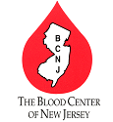
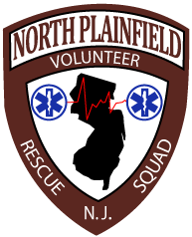

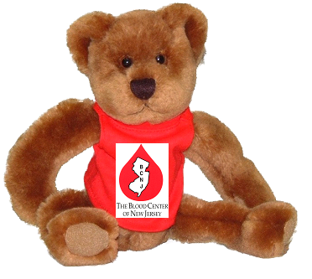

Saturday, November 6, 2010
Blood Drive 10:00a-3:00p
CPR Classes 3:00p-6:00a
Complimentary Refreshments/Gifts will be provided for blood donors
Massages/Chiropractor Screening will be given with donations to squad

Schedule your blood drive appointment online for faster service
Scroll to center of page and click on where it says
- “Have a password for a specific drive? Schedule your donation here”.
- Enter your e-mail address, birth date and sponsor code (33009) and click Login.
- Click on Saturday, November 6, 2010
Select an available appointment time.
- Our goal is 30pints so please spread the word!

We are located at North Plainfield Rescue Squad
334 Somerset Street
North Plainfield, NJ 07060

Contact Squad’s EMS Education Manager
Ellisa Lee 201-214-1022
Or
Public Relations Supervisor
Cristina Garzon 908-331-3679

