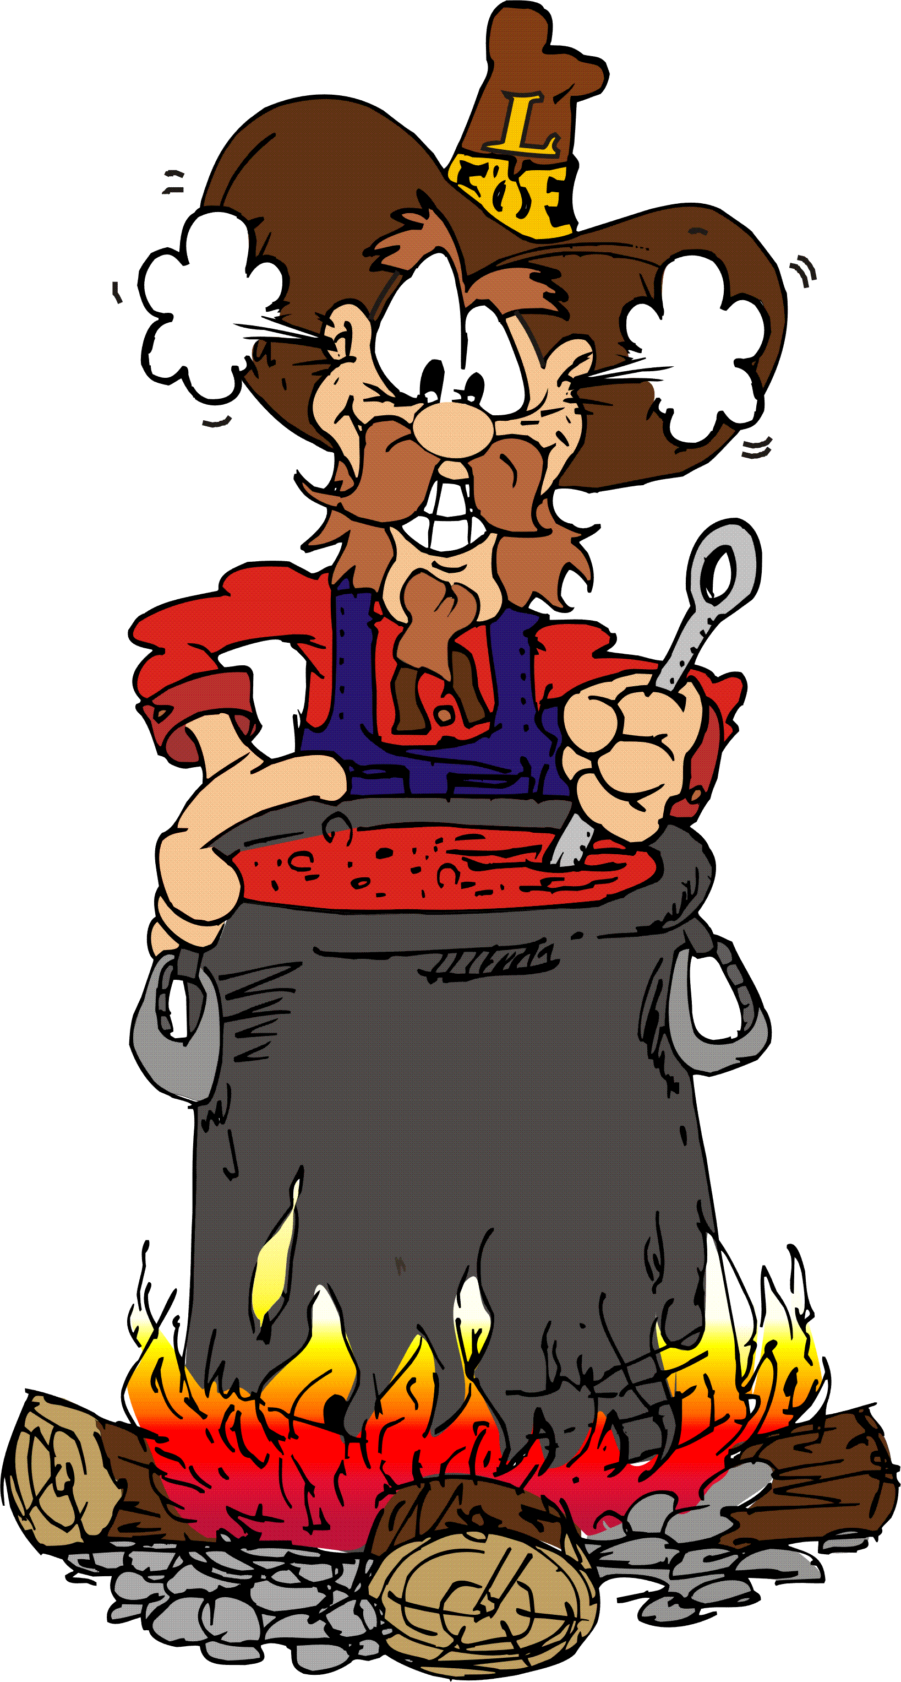
Rules & Information

North Plainfield Lions Chili Cook Off

1. The competition is open to all competitors - individuals or teams.

2. Your Chili recipe may contain any kind of meat or combination of meats, chili
peppers, spices and other ingredients, including beans or pasta.

3. A minimum of 2-3 gallons of chili is required to enter the competition.

4. You can make your Chili in advance to bring the day of the event.
Make sure Chili is cooked, cooled down and stored properly.

5. Contestants are responsible for supplying their own cooking equipment and utensils.
Contestants must also supply their own tent (10x10), table, chairs and booth
decorations. You will be assigned an area to set up and be supplied with
cups and spoons for tasting.

6. Provide a listing of ingredients and an estimated heat rating – scale 1 – 5.

Chili tips and helpful hints:

- The contestant who receives the most ballots will be Champion. Second, third and
fourth place will also be determined by number of ballots received.
Ballots are given to the public upon their entrance.

- The more chili you have, the more you can give out to increase your chances to
receive more votes.

- Your chili should be original enough to have it stand out from the rest, but not so
hot that you scorch the palate of those tasting. Anyone can make it hot, but your
culinary skills make it taste great.

- Have a unique chili name, a festive booth and showmanship to draw the public to
your booth for tasting.

- Have fun and bring your family and friends.

Those using any open flame are required to have a 5lb ABC fire extinguisher to comply with local fire regulations.
Electrical power will also be available.

